Example code:

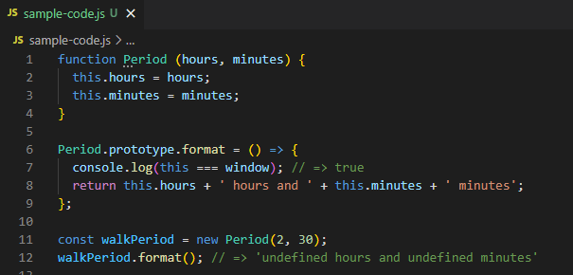

format is defined in the *global context* thus ‘this’ will always be *global object* (window)

Do not use arrow function in defining methods!

Solution: Use the function expression

